GCSE History

Course Overview
- Exam Board: AQA
- Usual Age Range: 14-16
- Qualification: GCSE
- Curriculum Time: three 50minute lessons per week
- Assessment: this curriculum is assessed via two external examinations:
- Paper One: 2hrs (worth 50%): Section A (6 questions); Section B (4 questions)
- Paper Two: 2hrs (worth 50%): Section A (4 questions); Section B (4 questions)
- Grading: 9-1
- Full specification from exam board:
https://www.aqa.org.uk/subjects/history/gcse/history-8145

Curriculum Intent
Purpose: In studying History, learners are encouraged to be curious and critical thinkers who develop their own opinions based upon respect for evidence, and a deeper understanding of the present day based upon engagement with and questioning of the past. Throughout their learning students will ‘develop a secure understanding of chronology, knowledge and understanding of history on different scales and contexts, apply historical concepts and processes and engage with the nature of evidence and interpretation’ (AQA) and in doing so gain an appreciation for the complexity of people’s lives as well as the process of change over time and its links to the modern world.

Implementation: History follows the AQA course. Key skills which are embedded at KS3 are built upon and developed at much greater depth at KS4, allowing students to strengthen their abilities and offer the opportunity to enhance their knowledge and understanding. Students will analyse and evaluate sources and interpretations to make substantiated judgements in the context of historical events. The study of Elizabethan England and British Health and the People c1000 to present day allow the chance to enrich knowledge of local and national situations in particular, whilst Conflict and Tension between the East and West 1945-72, and Democracy and Dictatorship in Germany 1890-1945 offer Historical international perspectives also through the interrogation of source materials and interpretations.

Impact: Workplace skills based around the scrutiny of ideas, the ordering of information and being able to reflect on others’ perspectives are all a crucial part of historical studies. History students are able offer their future employers evidence of their ability to: work without direct supervision and manage their time and priorities effectively; negotiate with others, approach problems and new situations with an open mind and a clear ability to evaluate information to form balances and informed opinions. The study of History enables students to stand out in an increasingly competitive job market because of the agile thinking and curiosity demanded by this subject, making it a highly valued qualification.

Remote learning and Revision
Students will benefit from wider reading around the subject and through frequent revision of knowledge to support recall. Producing timelines, concept maps and flashcards for key knowledge is extremely helpful as transforming information is the best way to take it in. Students can communicate with their teacher via Teams or email, and independently might find that other useful sources of support are:
https://quizlet.com/gb/topic/arts-and-humanities/history/
https://www.massolit.io/subjects/history (students are given their access when they join the UTC)
- Oak Academy: https://classroom.thenational.academy/subjects-by-key-stage/key-stage-4/subjects/history
- https://www.bbc.co.uk/bitesize/topics/zxgvfrd (Elizabeth I)
- https://www.bbc.co.uk/bitesize/topics/zskcg82 (Weimar Germany)
- https://www.bbc.co.uk/bitesize/topics/zpcbv4j (The Cold War and Vietnam)

Curriculum Overview
The learning in History is sequenced as follows:
Note: the full Curriculum Plans are available on request to info@nefuturesutc.co.uk
Year 10:
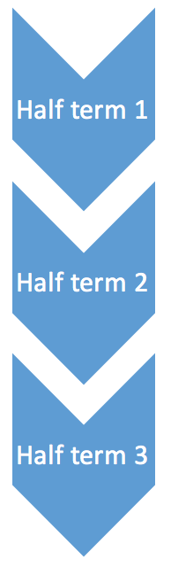
Germany 1890-1945 – Democracy and Dictatorship
- What difficulties did Kaiser Wilhelm face in ruling Germany?
- How was Germany affected by WW1 and the Stresemann era?
- Why did the Weimar Republic fail?
- How did Hitler become Fuhrer?

- Did the Nazis make Germany “self-sustainable”?
- How did living under Nazi rule affect aspects of German life?
(religion, women, youth, Jews, opposition)
Transition into…Conflict and Tension between East and West 1945-72
- How did the world start to rebuild after World War II?
- How did tensions develop between East and West following the post-war conferences?

- How significant were events in Asia for superpower relations?
- Why might events of the 1940s lead to a Berlin Blockade?
- How did advancements in technology impact on tensions between superpowers?
- Why was the Berlin Wall built?
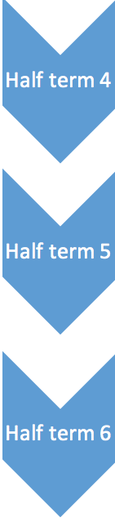
- Why did Cuba become a point of tension?
- Why did events in Hungary escalate and what was the impact of the Prague Spring?
- How far were tensions eased with Detente and SALT I?

Elizabethan England c1568-1603
- What was life like in the Court of Elizabeth 1 and how did Elizabeth's background and character impact on her time as a ruler?
- What were the difficulties of a female ruler?
- Was there really a 'Golden Age'? What was life like for the everyday person, and for the poorest?
- How did voyage and trade impact upon society during Elizabeth’s reign?

- How did religious matters threaten Elizabeth's reign?
- What were the difficulties that Mary Queen of Scots posed for Elizabeth I?
- Why were there tensions with Spain, and what were the consequences?
- What is the significance of a particular historical site, in relation to the Elizabethan period?
- What were the emerging challenges for Elizabeth towards the end of her reign?

Year 11:
British Health and the People
- How was public health dealt with in the middle ages?
- How do particular factors work together to bring about particular developments at this time?
- How and why have different factors contributed to medical progress?

- Why was there been progress in the health of the British people during the renaissance?
- What has been the impact of key individuals and ideas on medical progress in Britain?
- What role has government had on modern treatment of disease?

- Revision of areas of study and how to apply knowledge and understanding to questions

- Revision of areas of study and how to apply knowledge and understanding to questions

- Revision of areas of study and how to apply knowledge and understanding to questions
- Exams

- Exams

